## RDS Team Dynamics *Bi-Weekly Update*

**Assignment Goals / Deliverables:** Continuing the theme set with our first Team Dynamics assignment, we want you to get together with your team for a social activity either in-person or virtually (whichever you feel comfortable with). You can share a meal together, play a game, or something along those lines. This gathering should help you unwind a little, and allow you to reflect upon how your team has been performing over the last two weeks. As deliverables, we ask that you complete the following two tasks and upload them to the Canvas assignment:

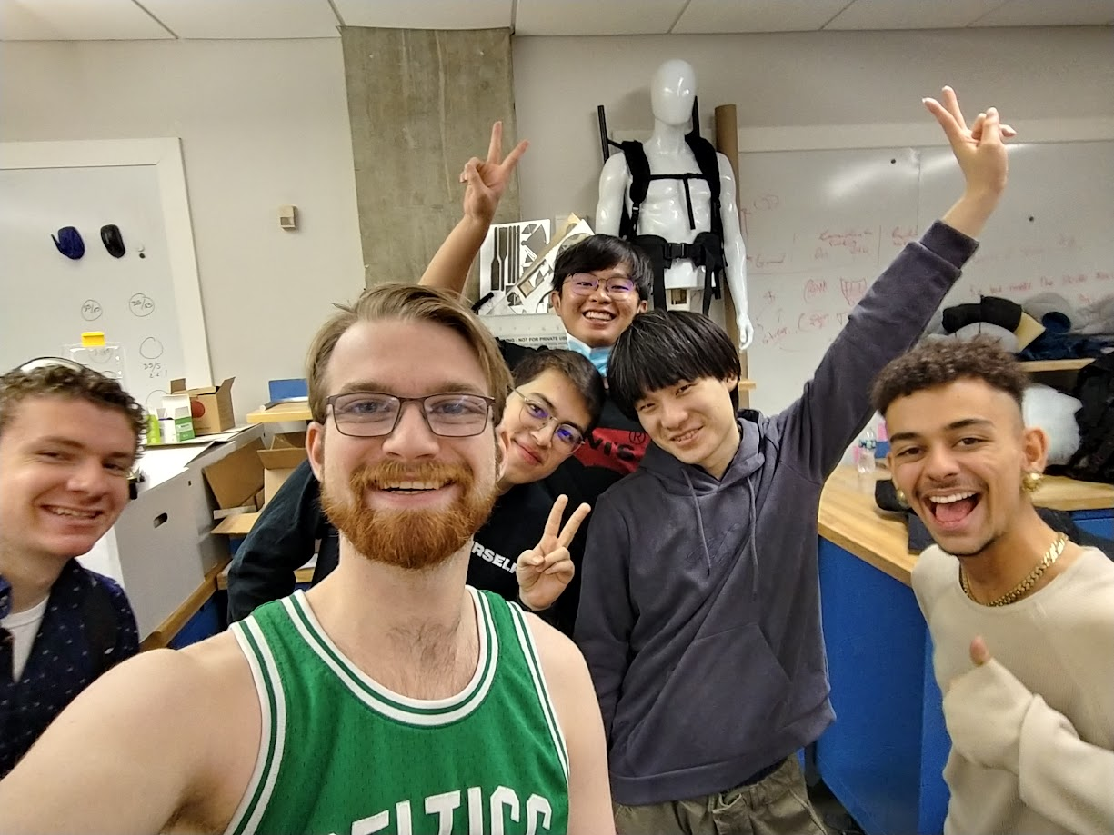

***Please be open and honest with yourselves and your group. There will be no penalties for the answers you provide in these bi-weekly updates, rather they should help you find areas for potential growth and help you recognize individual and team development.***

1. Have there been any conflicts or issues that have arisen within your team over the last two weeks? If so, what were they, and how were they resolved?

| We had a minor conflict about job allocation because there was a breakdown in communication about member's temporary inability to commit time to the project. However, we rectified this by communicating about how the team member would do additional work the next week to balance out the workload. |
| --- |

1. Are there any conflicts or issues within your team that are still outstanding that you would like to discuss during your next weekly meeting?

| No |
| --- |

1. Are there any areas where you feel your team is excelling?

| I think in the past week, being able to see the design come to life on the hardware side has been really exciting. We are definitely proud of our design on the mechanical side, and the magnet and control teams have also been seeing results |
| --- |

1. Are there any areas where you feel your team needs improvement?

| We really, really need to communicate about time well, and be willing to put in enough time. We are in the home stretch of this project, but it is also the most critical so we need to be on the ball in the final 6 weeks. |
| --- |